Name____________________________________________ Date_____________________________
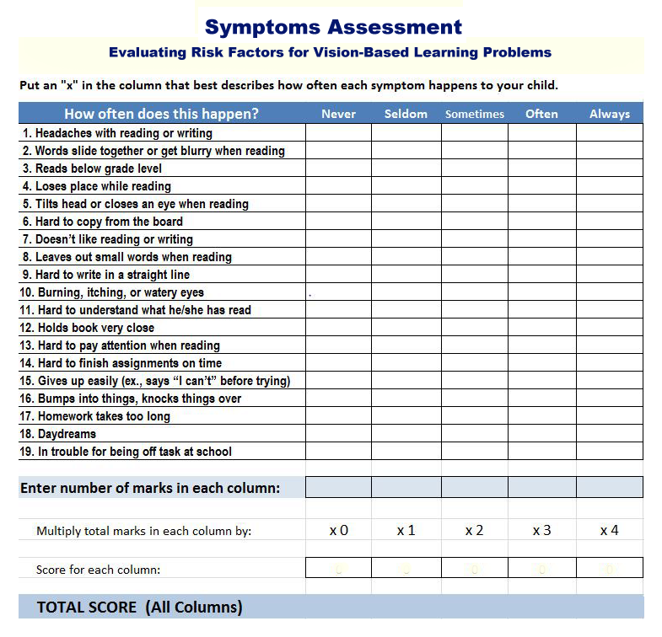
Interpreting the Results:
- Score below 20: Unlikely that vision is playing a large role in poor school performance
- 20-25: Fair possibility that poor visual skills are interfering with school performance
- 25-30: Likely probability that poor visual skills are interfering with school performance
- 30-35: Strong probability that poor visual skills are interfering with school performance
- Above 35: Near certainty that poor visual skills are interfering with school performance

